Rang | Pays Jeux Olympiques Pékin 2022 | Portes-Drapeaux | Sports | Quotas
001 | 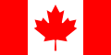 Canada | Tbd Tbd | Tbd Tbd | 048
002 | 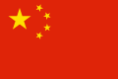 Chine | Tbd Tbd | Tbd Tbd | 048
003 | 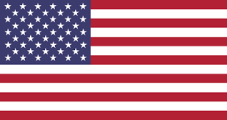 États-Unis | Tbd Tbd | Tbd Tbd | 048
004 | 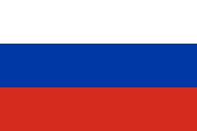 Russie | Tbd Tbd | Tbd Tbd | 048
005 | 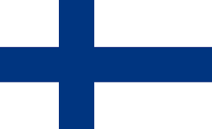 Finlande | Tbd Tbd | Tbd Tbd | 048
006 |  Suisse | Tbd Tbd | Tbd Tbd | 048
007 | 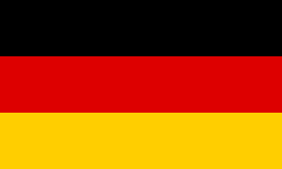 Allemagne | Tbd Tbd | Tbd Tbd | 025
008 | 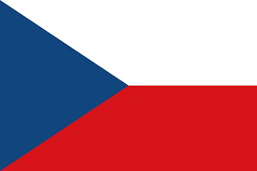 République Tchèque | Tbd Tbd | Tbd Tbd | 025
009 | 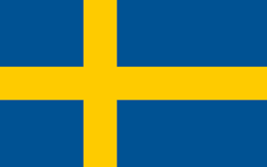 Suède | Tbd Tbd | Tbd Tbd | 025
010 | 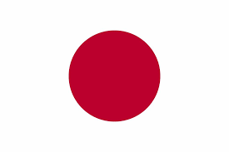 Japon | Tbd Tbd | Tbd Tbd | 023
011 | 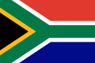 Afrique du Sud | Tbd Tbd | Tbd Tbd | 000
012 |  Albanie | Tbd Tbd | Tbd Tbd | 000
013 | 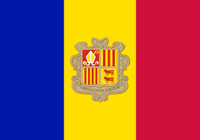 Andorre | Tbd Tbd | Tbd Tbd | 000
014 | 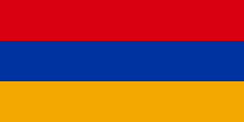 Arménie | Tbd Tbd | Tbd Tbd | 000
015 | 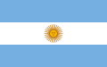 Argentine | Tbd Tbd | Tbd Tbd | 000
016 | 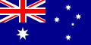 Australie | Tbd Tbd | Tbd Tbd | 000
017 |  Autriche | Tbd Tbd | Tbd Tbd | 000
018 | 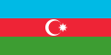 Azerbaïdjan | Tbd Tbd | Tbd Tbd | 000
019 | 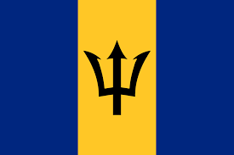 Barbade | Tbd Tbd | Tbd Tbd | 000
020 |  Belgique | Tbd Tbd | Tbd Tbd | 000
021 | 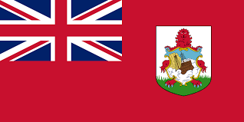 Bermudes | Tbd Tbd | Tbd Tbd | 000
022 | 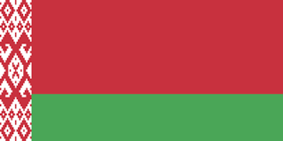 Biélorussie | Tbd Tbd | Tbd Tbd | 000
023 | 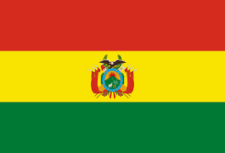 Bolivie | Tbd Tbd | Tbd Tbd | 000
024 | 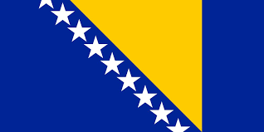 Bosnie-Herzégovine | Tbd Tbd | Tbd Tbd | 000
025 | 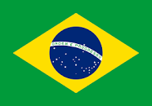 Brésil | Tbd Tbd | Tbd Tbd | 000
026 | 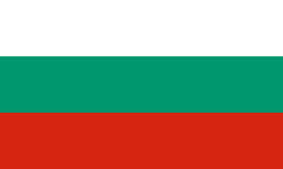 Bulgarie | Tbd Tbd | Tbd Tbd | 000
027 | 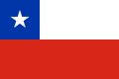 Chili | Tbd Tbd | Tbd Tbd | 000
028 |  Chine Taipei | Tbd Tbd | Tbd Tbd | 000
029 | 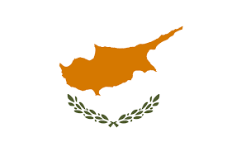 Chypre | Tbd Tbd | Tbd Tbd | 000
030 | 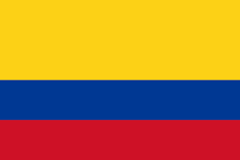 Colombie | Tbd Tbd | Tbd Tbd | 000
031 | 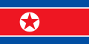 Corée du Nord | Tbd Tbd | Tbd Tbd | 000
032 | 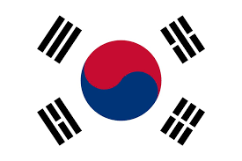 Corée du Sud | Tbd Tbd | Tbd Tbd | 000
033 | 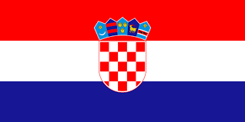 Croatie | Tbd Tbd | Tbd Tbd | 000
034 | 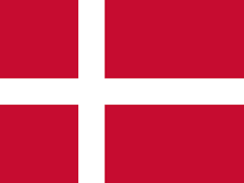 Danemark | Tbd Tbd | Tbd Tbd | 000
035 | 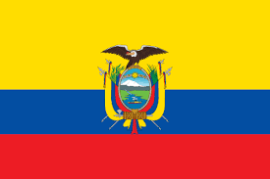 Équateur | Tbd Tbd | Tbd Tbd | 000
036 | 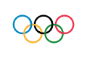 Équipe des Réfugiés | Tbd Tbd | Tbd Tbd | 000
037 | 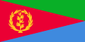 Érythrée | Tbd Tbd | Tbd Tbd | 000
038 | 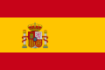 Espagne | Tbd Tbd | Tbd Tbd | 000
039 |  Estonie | Tbd Tbd | Tbd Tbd | 000
040 | 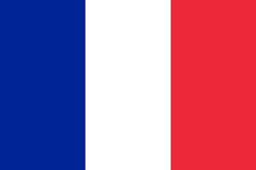 France | Tbd Tbd | Tbd Tbd | 000
041 | 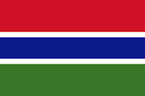 Gambie | Tbd Tbd | Tbd Tbd | 000
042 | 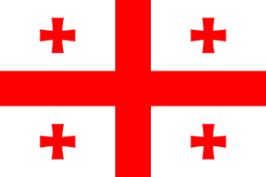 Géorgie | Tbd Tbd | Tbd Tbd | 000
043 | 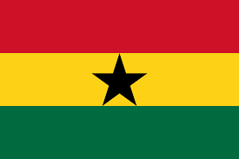 Ghana | Tbd Tbd | Tbd Tbd | 000
044 | 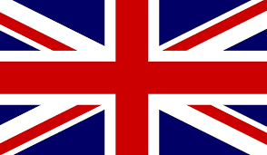 Grande-Bretagne | Tbd Tbd | Tbd Tbd | 000
045 | 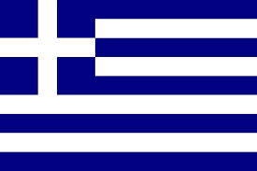 Grèce | Tbd Tbd | Tbd Tbd | 000
046 | 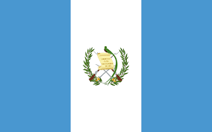 Guatemala | Tbd Tbd | Tbd Tbd | 000
047 | 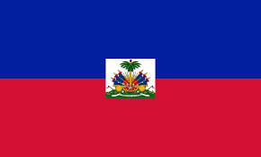 Haïti | Tbd Tbd | Tbd Tbd | 000
048 | 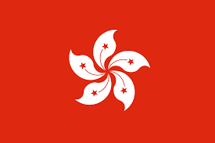 Hong-Kong | Tbd Tbd | Tbd Tbd | 000
049 |  Hongrie | Tbd Tbd | Tbd Tbd | 000
050 |  Îles Vierges Américaines | Tbd Tbd | Tbd Tbd | 000
051 | 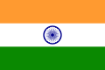 Inde | Tbd Tbd | Tbd Tbd | 000
052 | 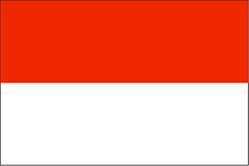 Indonésie | Tbd Tbd | Tbd Tbd | 000
053 | 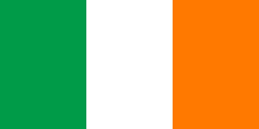 Irlande | Tbd Tbd | Tbd Tbd | 000
054 | 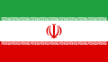 Iran | Tbd Tbd | Tbd Tbd | 000
055 | 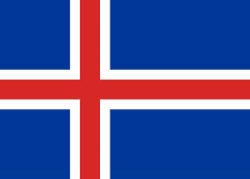 Islande | Tbd Tbd | Tbd Tbd | 000
056 | 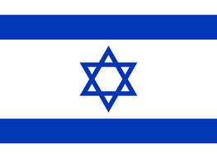 Israël | Tbd Tbd | Tbd Tbd | 000
057 | 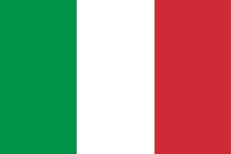 Italie | Tbd Tbd | Tbd Tbd | 000
058 | 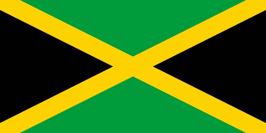 Jamaïque | Tbd Tbd | Tbd Tbd | 000
059 | 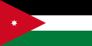 Jordanie | Tbd Tbd | Tbd Tbd | 000
060 |  Kazakhstan | Tbd Tbd | Tbd Tbd | 000
061 | 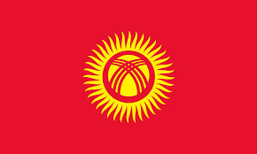 Kirghizstan | Tbd Tbd | Tbd Tbd | 000
062 | 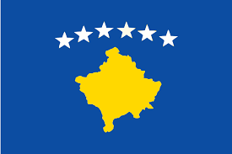 Kosovo | Tbd Tbd | Tbd Tbd | 000
063 |  Lettonie | Tbd Tbd | Tbd Tbd | 000
064 | 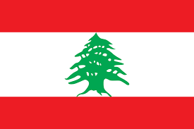 Liban | Tbd Tbd | Tbd Tbd | 000
065 | 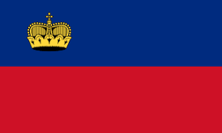 Liechtenstein | Tbd Tbd | Tbd Tbd | 000
066 |  Lituanie | Tbd Tbd | Tbd Tbd | 000
067 |  Luxembourg | Tbd Tbd | Tbd Tbd | 000
068 |  Macédoine du Nord | Tbd Tbd | Tbd Tbd | 000
069 | 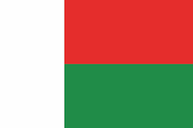 Madagascar | Tbd Tbd | Tbd Tbd | 000
070 | 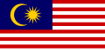 Malaisie | Tbd Tbd | Tbd Tbd | 000
071 | 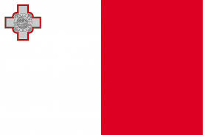 Malte | Tbd Tbd | Tbd Tbd | 000
072 | 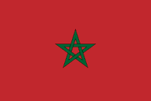 Maroc | Tbd Tbd | Tbd Tbd | 000
073 | 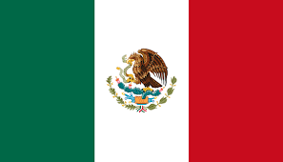 Mexique | Tbd Tbd | Tbd Tbd | 000
074 | 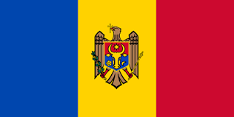 Moldavie | Tbd Tbd | Tbd Tbd | 000
075 | 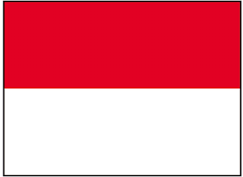 Monaco | Tbd Tbd | Tbd Tbd | 000
076 | 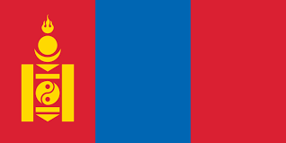 Mongolie | Tbd Tbd | Tbd Tbd | 000
077 | 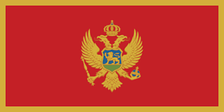 Monténégro | Tbd Tbd | Tbd Tbd | 000
078 | 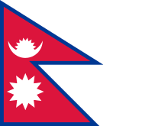 Népal | Tbd Tbd | Tbd Tbd | 000
079 |  Nigeria | Tbd Tbd | Tbd Tbd | 000
080 | 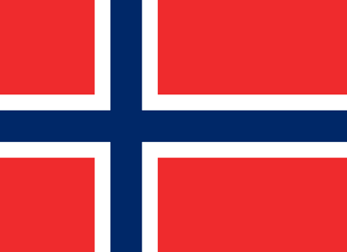 Norvège | Tbd Tbd | Tbd Tbd | 000
081 | 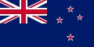 Nouvelle-Zélande | Tbd Tbd | Tbd Tbd | 000
082 | 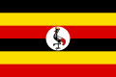 Ouganda | Tbd Tbd | Tbd Tbd | 000
083 | 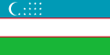 Ouzbékistan | Tbd Tbd | Tbd Tbd | 000
084 |  Pakistan | Tbd Tbd | Tbd Tbd | 000
085 | 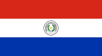 Paraguay | Tbd Tbd | Tbd Tbd | 000
086 | 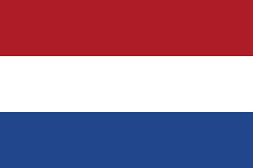 Pays-Bas | Tbd Tbd | Tbd Tbd | 000
087 | 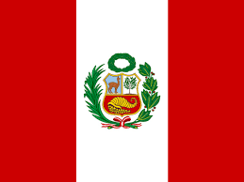 Pérou | Tbd Tbd | Tbd Tbd | 000
088 | 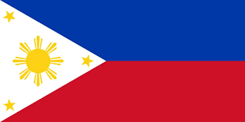 Philippines | Tbd Tbd | Tbd Tbd | 000
089 | 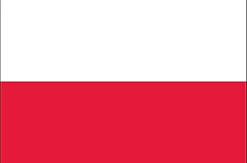 Pologne | Tbd Tbd | Tbd Tbd | 000
090 | 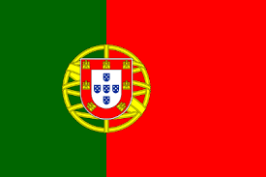 Portugal | Tbd Tbd | Tbd Tbd | 000
091 |  Qatar | Tbd Tbd | Tbd Tbd | 000
092 | 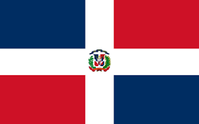 République Dominicaine | Tbd Tbd | Tbd Tbd | 000
093 | 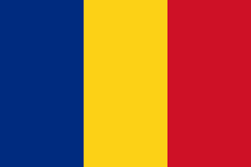 Roumanie | Tbd Tbd | Tbd Tbd | 000
094 | 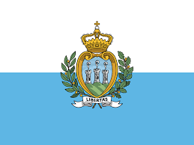 Saint-Marin | Tbd Tbd | Tbd Tbd | 000
095 | 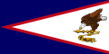 Samoa Américaines | Tbd Tbd | Tbd Tbd | 000
096 | 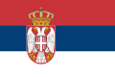 Serbie | Tbd Tbd | Tbd Tbd | 000
097 | 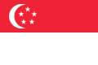 Singapour | Tbd Tbd | Tbd Tbd | 000
098 | 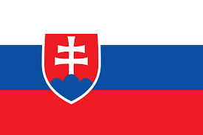 Slovaquie | Tbd Tbd | Tbd Tbd | 000
099 | 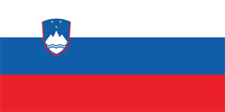 Slovénie | Tbd Tbd | Tbd Tbd | 000
100 | 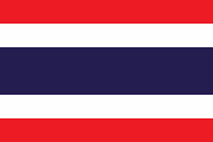 Thaïlande | Tbd Tbd | Tbd Tbd | 000
101 | 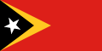 Timor Oriental | Tbd Tbd | Tbd Tbd | 000
102 |  Tonga | Tbd Tbd | Tbd Tbd | 000
103 | 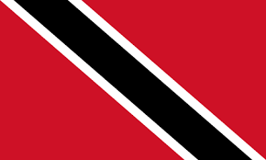 Trinité-et-Tobago | Tbd Tbd | Tbd Tbd | 000
104 | 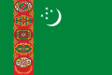 Turkménistan | Tbd Tbd | Tbd Tbd | 000
105 | 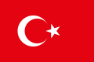 Turquie | Tbd Tbd | Tbd Tbd | 000
106 | 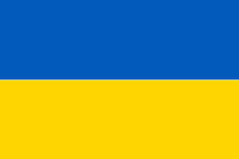 Ukraine | Tbd Tbd | Tbd Tbd | 000
107 | 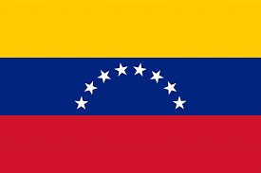 Venezuela | Tbd Tbd | Tbd Tbd | 000

